Hopper vs. Google Fiber TV Comparison

This is a comparison of Google Fiber TV (GFTV) to the Hopper 2000 (H2K). I’m assuming reader familiarity with the interface and features of the Hopper platform.

Platform Overview
GFTV is an IPTV solution. It comes as an add-on package to the Google Fiber Gigabit internet service. It cannot be purchased as a standalone service. It cannot be purchased with the basic free 5Mbps service Google offers. The platform is based on the SageTV system that Google purchased in 2011.

Hardware
Overview
GFTV consists of a central DVR/Server Google calls the “Storage Box”. Each TV receives a client box called a “TV Box” The Storage Box connects via Ethernet to Google Fiber router, which they call the “Network Box” (By now the reader probably realizes Google is striving for simplicity.) The Storage box connects to the TV Box via either Ethernet or coax/MOCA. The Storage Box has a built-in MOCA adapter.

The TV Box connects to the TV via HDMI or an analog breakout cable containing composite and component cables. There is also a TOSLink optical port. The analog/optical ports seem to disable when HDMI is in use. Below are some side-by-side pictures of the GFTV and H2K hardware
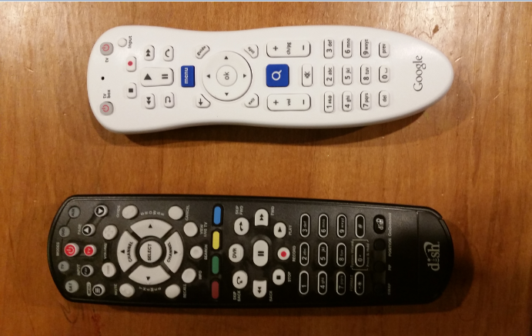
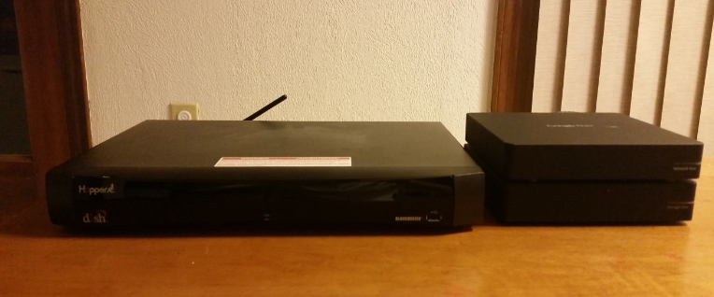
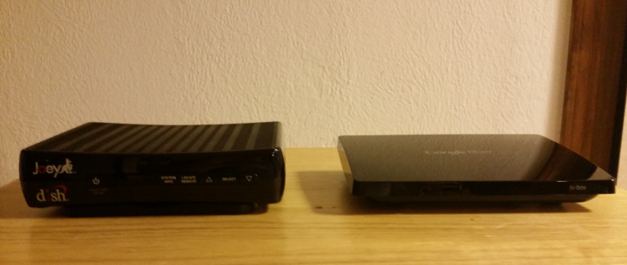

Comparison
Remote
The GFTV remote wins for simplicity. The H2K remote is more versatile. The GFTV remote can only control a TV and a TV Box. It also lacks a dedicated DVR button (actually a limitation of the UI) and a “Live TV” button. If you get behind live TV and want to catch up you have to scan forward until you catch up.

TV Box/Joey
The TV Box and the Joey are very similar. Both are simple clients for the main unit. Both can also connect via MOCA or Ethernet (Ironically, like Dish, Google does not heavily promote Ethernet for connectivity. Default installs are via coax). The TV Box gets a few extra points for supporting analog HD Out where the Joey only has HDMI or SD Composite.
Storage Box/Hopper
Like the TV Box and Joey both perform the same function. The Storage Box has 2TB or storage like the H2K. The storage box does not connect to a TV. Max TV’s connected for GFTV is 4, like the H2K. The Storage Box can record up 8 programs at once vs. the H2K max of 6 (w/Prime-Time Anytime). The Storage Box has no input for OTA or phone.

User Interface
Overview
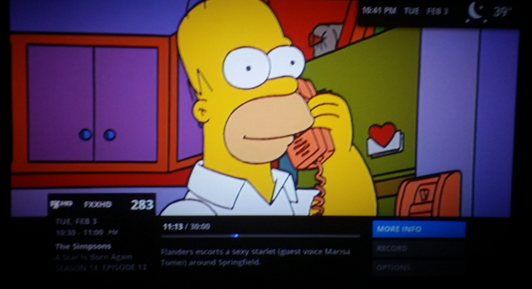
As mentioned above the GFTV UI is based on SageTV. It is a GUI-based interface. Below are some screenshots of the basic screens
The basic screen with channel/episode info that comes up when you tune to a channel

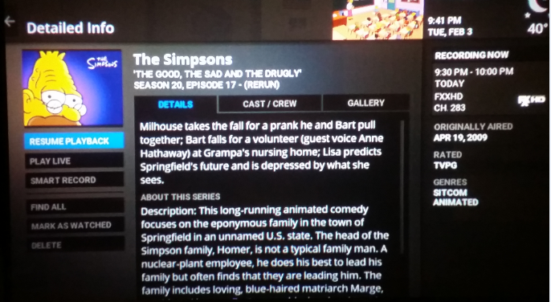
The expanded info screen from the “more info” option

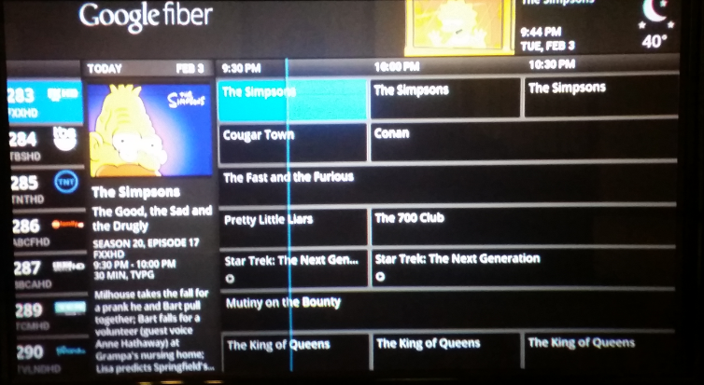
Interactive guide

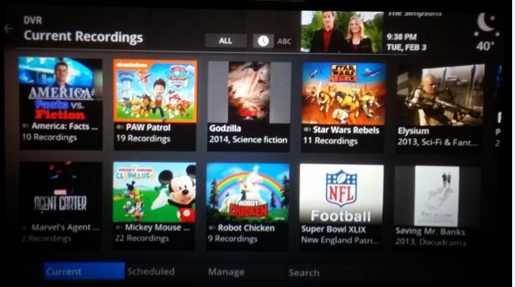
Main DVR menu

Comparison
The basic concepts of interaction are very similar to the H2K UI. GFTV uses different terms for the same function. Instead of “Timers” GFTV has “Smart Recordings”. Management of scheduled programs is similar. One nice feature I found when setting a recording for the Super Bowl was that for a live program you get an extra pop-up reminding you it’s a live event and offering to extend recording longer than the system default overlap time. I have not found the max number of smart recordings yet. On the guide there is a blue line showing you how far into that time slot your currently are. I like the weather in the top right corner.

The UI is responsive. It scrolls through the guide or search results quickly. Changing channels happens quickly. Overall it’s taking me longer to learn the new channel numbers than the UI.

Apps and other features
Overview
GFTV has built-in apps for Netflix, YouTube and Vudu. There is also an option to upload personal photos, music and videos to the Storage Box and there are apps to access them. More detailed weather info is also available
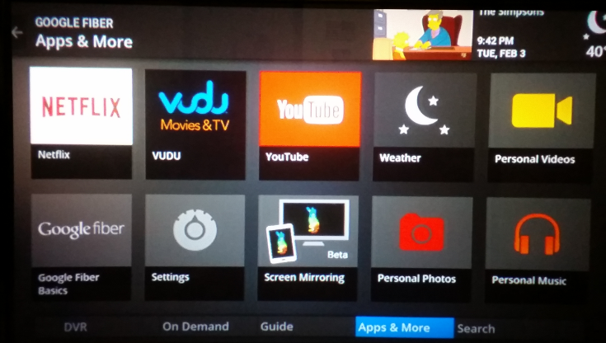
The main apps & more menu
Comparison
In this category I think the H2K definitely has the edge. Even more so for the new Hopper with Sling that recently added the Netflix app. I really liked the Game Finder app on the H2K. It was very helpful finding the baseball and basketball games as they are often all over the channel range. The H2K also has DLNA functions GFTV lacks. I really miss the caller ID on-screen. Many have suggested allowing the TV Box to also function as a Chromecast as that would open up a great deal of app functionality.

One handy feature of GFTV though is that for each TV Box you can use a different Netflix or Vudu account on each box. Also if you choose you can include Netflix and Vudu in searches for TV shows or movies.

Remote Access
Overview
GFTV has an app available for both Android and iOS. It can function as the remote control for any TV Box on the network. There is limited viewing of live TV. Certain channels can be viewed, but the premium channels (HBO, Showtime, etc) are not available. DVR recorded shows cannot be viewed from the app. There are no DVR management functions available. The app does not function outside the home network.
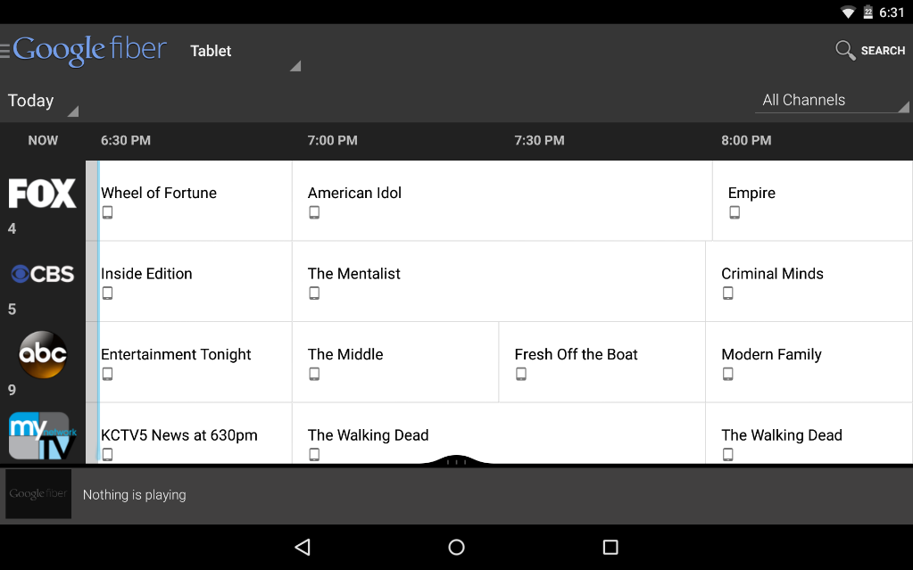
Google Fiber app from Nexus 7 Tablet

Comparison
In this case I feel there is no comparison. Dish’s Dish Anywhere app coupled with a Sling Adapter is probably the best Place-shifting/TV Anywhere feature of any of the pay TV carriers. This is probably the feature I miss most from my H2K. The TV Boxes are fully compatible with a stand-alone Slingbox, but that is an extra cost for the Slingbox and the app.

Misc.
Picture Quality
Google sends the channel in its full resolution format with no additional compression. According to Google each HD channel uses about 15Mbps. Does it look better than H2K? This is obviously a very subjective question. I have 3 TV’s: An HD RPTV that uses component and has a native resolution of 1080i, an LCD HDTV that is 720p via HDMI and a Plasma HDTV that is also 720p via HDMI. To my eyes the RPTV has a noticeably better picture. The Plasma and LCD are about the same with a better performance on dark scenes.

Wi-Fi
The GFTV TV Boxes can also be Wi-Fi access points so they can help spread the Wi-Fi signal throughout your house. The first generation of GFTV hardware can broadcast 802.11n. The second generation of hardware that has seen limited deployment in my area is capable of broadcasting 802.11ac. I have the first generation hardware.

Speaking of Wi-Fi there is currently no Wi-Fi version of the TV Box. Both generations of hardware are wired-connectivity only.

Channel Lineup
I’m not going to do a channel-by-channel comparison. There are a few noticeable differences, though. The big one is that GFTV does not have AMC. It doesn’t matter to me as I am not a fan of any AMC shows, but it is deal-breaker for many. The big package missing for me is the Epix channels. On the plus side GFTV has a number of channels in HD that Dish does not. These include AHC and many of the sub-channels in the Cinemax, Showtime and Movie Channel packages.

For the curious here is the full channel lineup for GFTV:
https://fiber.google.com/cities/kansascity/channels/

Final Thoughts
While I miss several channels and minor features I don’t regret making the switch. The more I use the system the more comfortable I am with it. In terms of functionality and feature I think the Hopper platform is still superior overall. However the things I miss are offset by the significant cost savings I’m seeing.

